SOC HOME LAB
Project Documentation

Prepared by: Kishore Gandi
Date: March 14, 2026 | Role: SOC Analyst (Fresher)

Project Summary
Built a complete SOC home lab using VirtualBox, Kali Linux, and Wazuh SIEM v4.14.3.
Simulated real-world cyberattacks including brute force and privilege escalation.
Detected and analyzed 635+ security events using Wazuh SIEM.
Mapped attack techniques to MITRE ATT&CK framework.
Performed vulnerability assessment and CIS compliance checking.

Category | Details
Project Type | SOC Home Lab / Blue Team Cybersecurity
Duration | 1 Week - March 2026
SIEM Tool | Wazuh v4.14.3
Attacker | Kali Linux
Victim Machine | Windows 11 Home (DESKTOP-2VE1QV7)
Total Events | 635+ Security Events Detected
MITRE Tactics | Privilege Escalation, Persistence, Defense Evasion
Compliance | CIS Microsoft Windows 11 Benchmark v3.0.0

1. Project Overview

This project demonstrates the setup and operation of a Security Operations Center (SOC) home lab environment. The lab was built from scratch using free and open-source tools to simulate real-world cybersecurity scenarios including attack detection, threat hunting, vulnerability assessment, and compliance monitoring.

1.1 Objectives
- Design and deploy a fully functional SOC home lab environment
- Configure Wazuh SIEM to collect and analyze security events in real-time
- Simulate real-world cyberattacks and detect them using the SIEM
- Map detected threats to the MITRE ATT&CK framework
- Perform vulnerability assessment and CIS compliance checking
- Document all findings in professional incident report format

1.2 Skills Demonstrated
Skill Area | Tools / Techniques
SIEM Management | Wazuh v4.14.3, Log analysis, Alert triage
Threat Detection | Brute force detection, Privilege escalation monitoring
Vulnerability Assessment | CVE analysis, Package vulnerability scanning
Compliance Monitoring | CIS Benchmark, PCI DSS mapping
Threat Intelligence | MITRE ATT&CK framework mapping
Network Security | Host-only networking, Firewall configuration
Incident Response | Alert investigation, Incident report writing

2. Lab Architecture

The lab consists of three virtual machines running inside Oracle VirtualBox, connected via a Host-Only private network ensuring complete isolation from the internet and production systems.

2.1 Network Topology
Lab Network Diagram
[ Kali Linux - Attacker ] ──attacks──> [ Windows 11 - Victim ]
192.168.56.x 192.168.56.10
| |
└──── Host-Only Network ────────────┘
192.168.56.0/24
|
[ Wazuh SIEM v4.14.3 Monitor ]
192.168.56.3
|
[ Analyst Browser Dashboard ]

2.2 Lab Components
Component | Specification
Attacker Machine | Kali Linux - IP: 192.168.56.x
Victim Machine | Windows 11 Home (DESKTOP-2VE1QV7) - IP: 192.168.56.10
SIEM Monitor | Wazuh v4.14.3 - IP: 192.168.56.3
Hypervisor | Oracle VirtualBox 7.2.2
Network Type | Host-Only (192.168.56.0/24) - Fully Isolated
Wazuh Agent ID | 001 - Active

2.3 Victim Machine Specifications
Specification | Value
Hostname | DESKTOP-2VE1QV7
Operating System | Microsoft Windows 11 Home 10.0.26200.8037
IP Address | 192.168.56.10
CPU | 12th Gen Intel Core i5-1235U - 12 Cores
Memory | 7.7 GB RAM
Wazuh Agent | v4.14.3 - Active
Registration Date | March 14, 2026 @ 11:38:29

3. Wazuh SIEM Setup & Agent Deployment

Wazuh is an open-source security platform providing unified XDR and SIEM capabilities. It was deployed as a pre-built OVA virtual machine and configured to monitor the Windows 11 endpoint through an installed agent.

3.1 Endpoints Dashboard - Active Agent
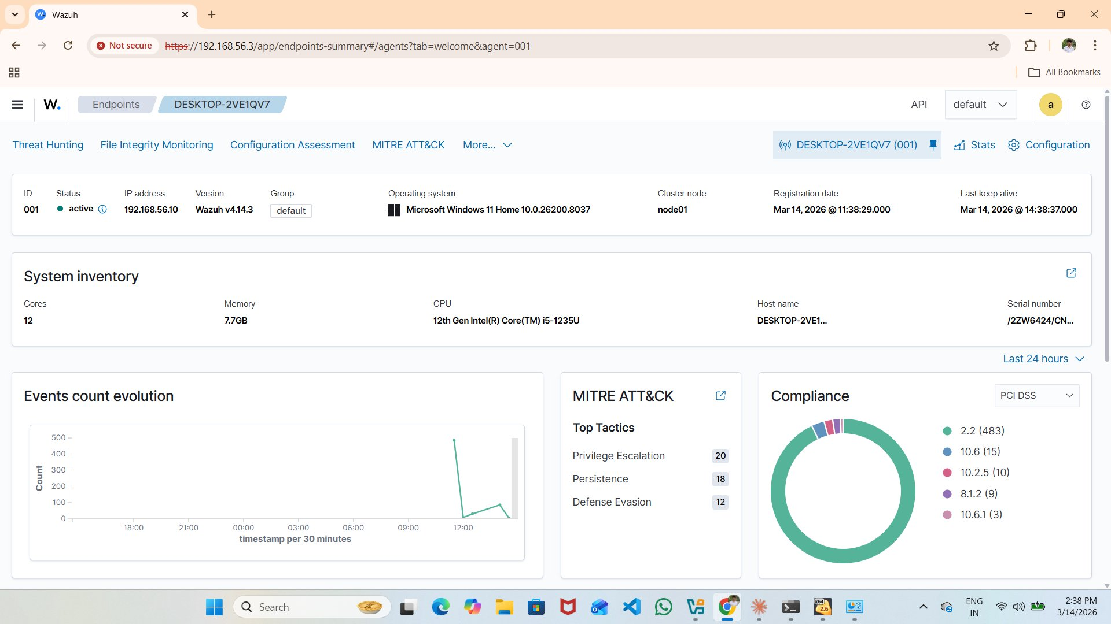
Figure 1: Wazuh Endpoints Dashboard - 1 Active Agent (DESKTOP-2VE1QV7, Windows 11, IP: 192.168.56.10)
Setting | Value
Agent ID | 001
Agent Name | DESKTOP-2VE1QV7
IP Address | 192.168.56.10
Status | Active
OS | Microsoft Windows 11 Home
Wazuh Version | v4.14.3
Cluster Node | node01

3.2 Agent Overview - MITRE ATT&CK & Events
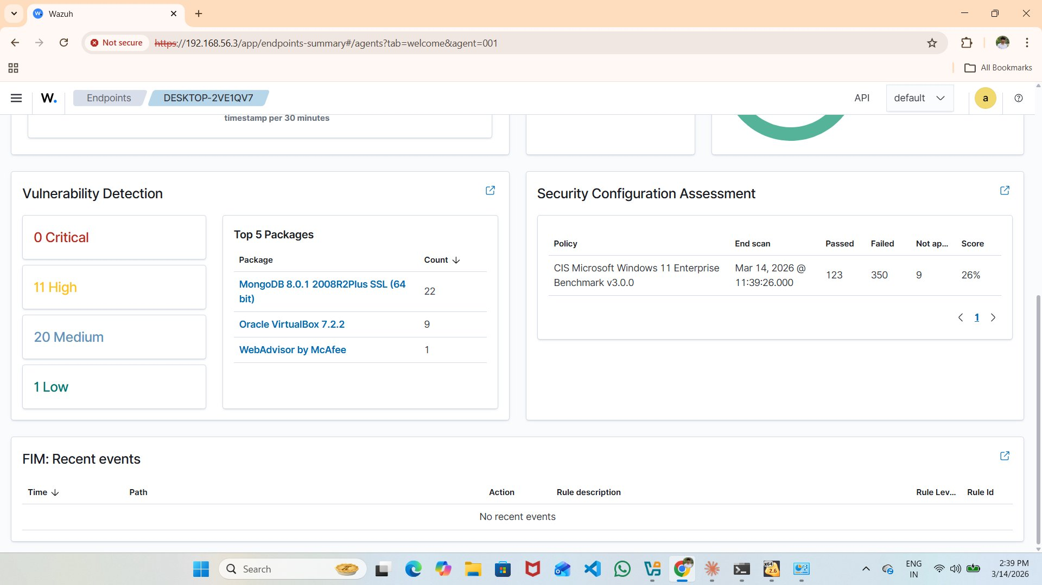
Figure 2: Agent Detail showing Events Count Evolution, MITRE ATT&CK Top Tactics and PCI DSS Compliance
The agent dashboard shows real-time event monitoring with MITRE ATT&CK tactic mapping. Top tactics include Privilege Escalation (20), Persistence (18), and Defense Evasion (12).

4. Security Events & Threat Detection

4.1 Threat Hunting Dashboard - 635 Total Events
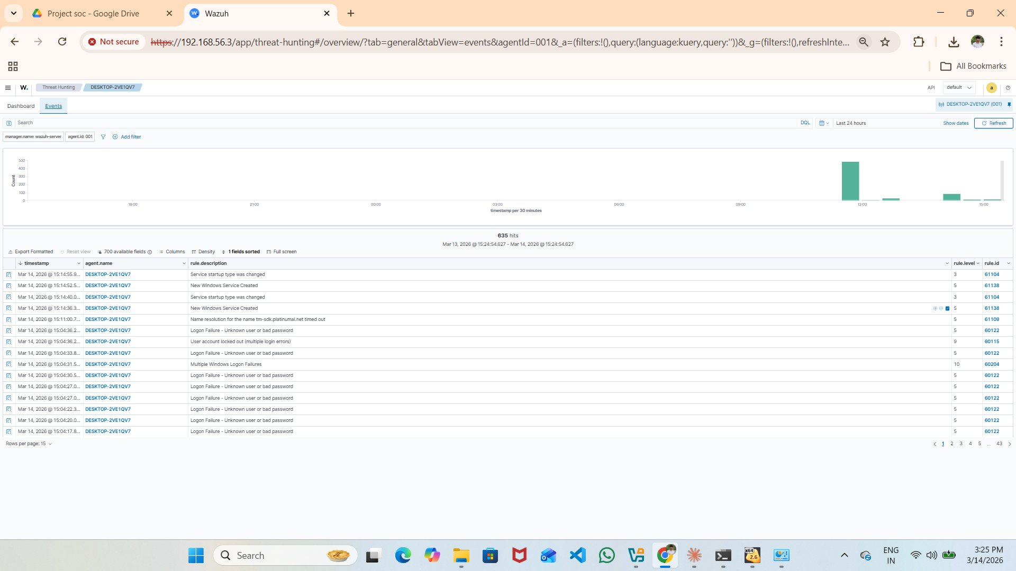
Figure 3: Wazuh Threat Hunting Dashboard - 635 Total Events, 11 Authentication Failures in 24 Hours
Metric | Value
Total Security Events | 635
Level 12+ Critical Alerts | 0
Authentication Failures | 11
Authentication Success | 0
Time Period | Last 24 Hours
Agent Monitored | DESKTOP-2VE1QV7 (ID: 001)

4.2 Threat Hunting Dashboard - 608 Events (Earlier Snapshot)
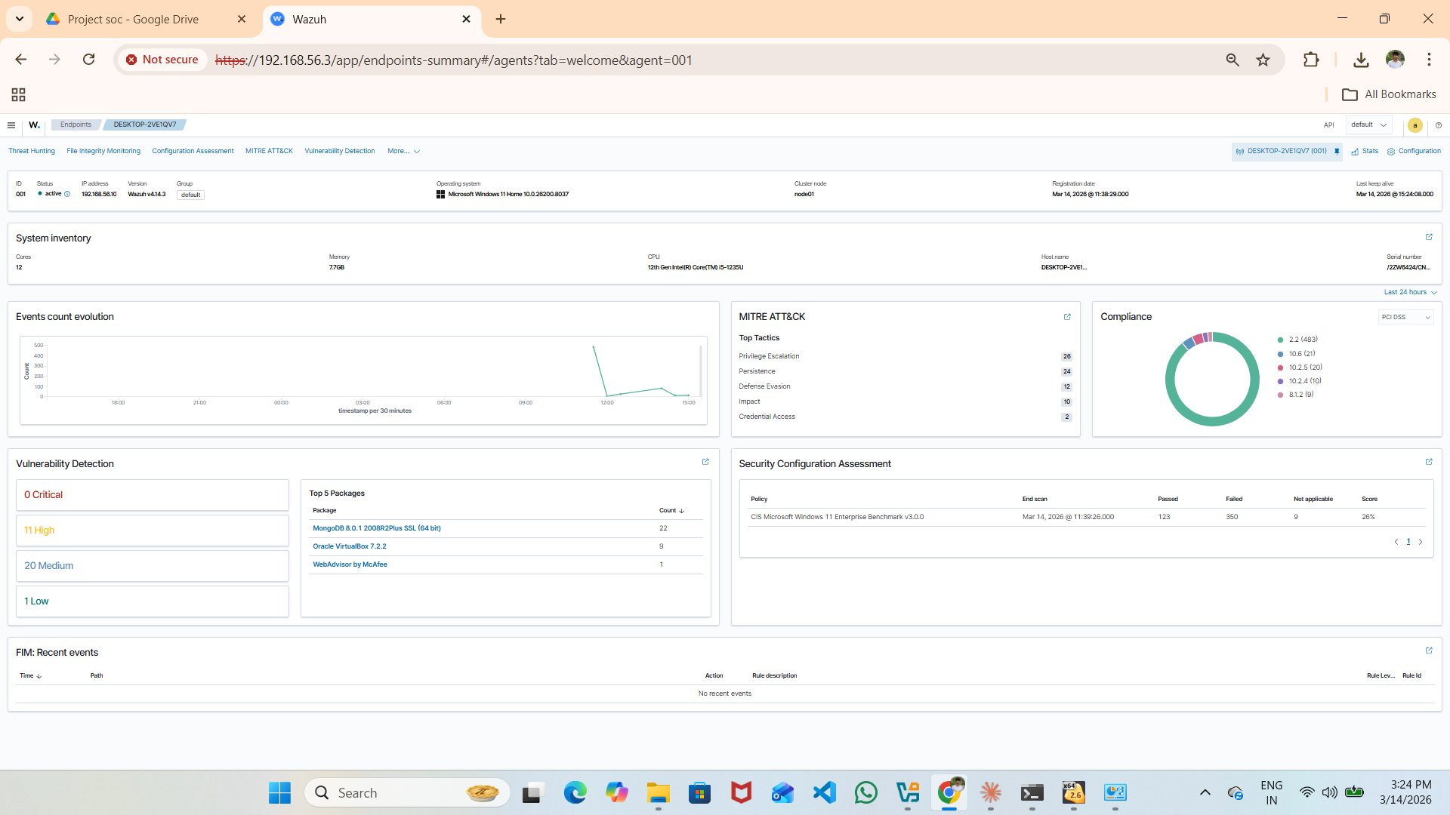
Figure 4: Earlier Threat Hunting Snapshot showing 608 Events with Top Alert Groups Evolution Chart
Alert groups detected include: SCA, windows, WEF, windows_system, windows_application, policy_changed, windows_security, account_changed, authentication_failed, system_error, and osxsec categories.

4.3 Detailed Security Events Log
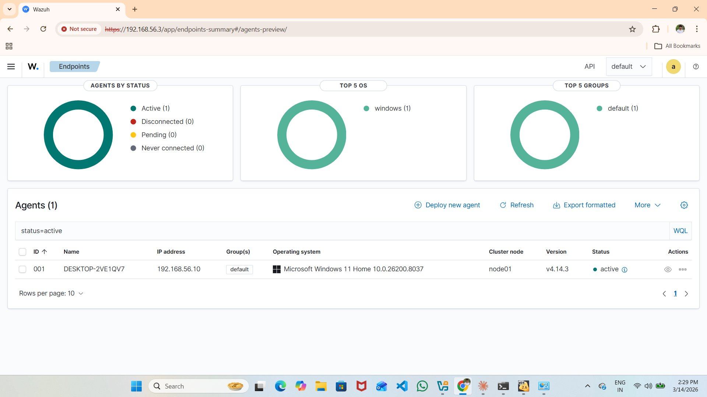
Figure 5: Exported Security Events showing Logon Failures, Account Lockouts, Service Creation and Privilege Escalation Events
Key security events detected and recorded during the attack simulation:

Event Description | Rule ID / Level
Logon Failure - Unknown user or bad password | Rule 60122 / Level 5
Multiple Windows Logon Failures | Rule 60204 / Level 10
User account locked out (multiple login errors) | Rule 60115 / Level 9
New Windows Service Created | Rule 61138 / Level 5
Service startup type was changed | Rule 61104 / Level 3
User account changed | Rule 60110 / Level 8
Special privileges assigned to new logon | Rule 67028 / Level 3
Non network or service local logon | Rule 67022 / Level 5
Windows System error event | Rule 61102 / Level 5
Name resolution failure for suspicious domain | Rule 61109 / Level 5

5. MITRE ATT&CK Framework Mapping

All detected attack techniques were mapped to the MITRE ATT&CK framework, providing a standardized way to describe and categorize adversary behaviors observed during the lab exercises.

MITRE ATT&CK Tactic | Event Count
Privilege Escalation | 20 events
Persistence | 18 events
Defense Evasion | 12 events
Impact | 10 events
Credential Access | 2 events

Privilege Escalation (20 events)
Special privileges were assigned to new logon sessions.
User account modifications indicated privilege level changes.
Attackers attempted to gain higher level access on the target system.

Persistence (18 events)
New Windows services were created during the attack period.
Service startup types were modified to ensure persistence across reboots.
These techniques maintain attacker access after system restart.

Defense Evasion (12 events)
Account changes were made to blend in with normal activity.
Non-standard logon types used to avoid triggering standard alerts.
Service modifications used to hide malicious activity from defenders.

6. Vulnerability Assessment

6.1 Vulnerability Detection Results
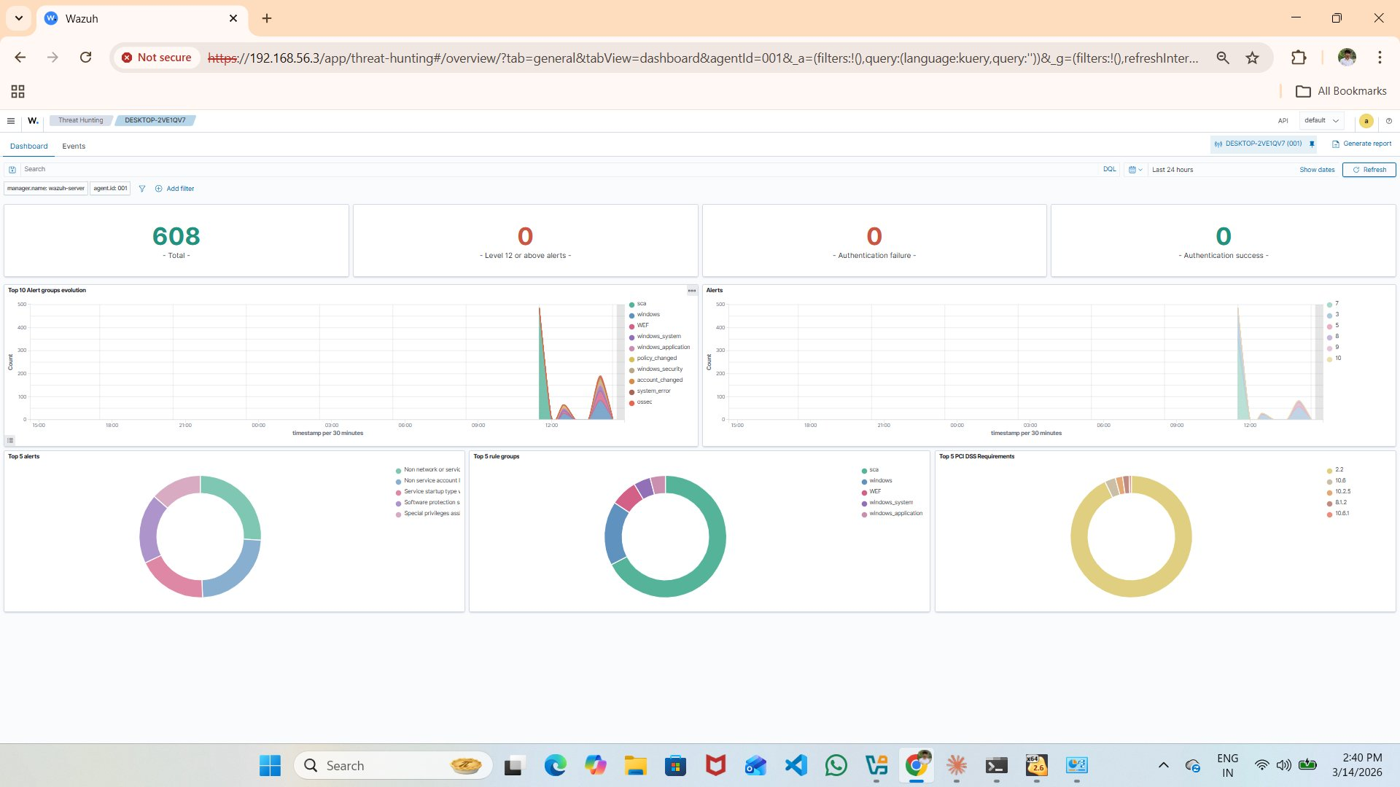
Figure 6: Vulnerability Detection showing 0 Critical, 11 High, 20 Medium, 1 Low - Top Vulnerable Packages
Severity | Count
Critical | 0
High | 11
Medium | 20
Low | 1
Total | 32 Vulnerabilities

6.2 Top Vulnerable Packages
Package | Vulnerability Count
MongoDB 8.0.1 2008R2Plus SSL (64 bit) | 22 vulnerabilities
Oracle VirtualBox 7.2.2 | 9 vulnerabilities
WebAdvisor by McAfee | 1 vulnerability

Recommendation: Update MongoDB and VirtualBox to their latest versions immediately to reduce the attack surface. The 11 high-severity vulnerabilities should be patched as priority.

7. Compliance & Configuration Assessment

7.1 Full Agent Security Dashboard
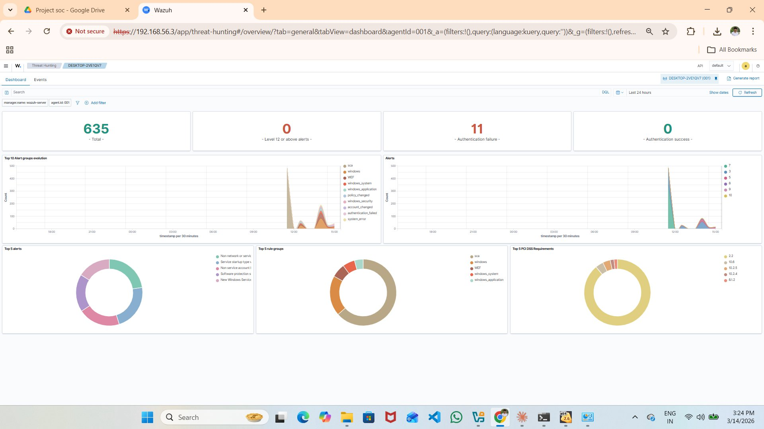
Figure 7: Complete Agent Security Dashboard showing Vulnerability Detection, MITRE ATT&CK, Compliance and FIM

7.2 CIS Benchmark Assessment
Assessment Item | Value
Policy | CIS Microsoft Windows 11 Enterprise Benchmark v3.0.0
Scan Date | March 14, 2026 @ 11:39:26
Passed Controls | 123
Failed Controls | 350
Not Applicable | 9
Compliance Score | 26%

Compliance Analysis
Current compliance score: 26% against CIS Benchmark.
123 of 482 applicable controls are passing.
350 controls failed - major hardening opportunities exist.
Priority areas: Password policies, audit logging, network security, application whitelisting.
Target: Achieve 70%+ compliance by implementing recommended hardening steps.

7.3 PCI DSS Compliance Mapping
PCI DSS Requirement | Events
2.2 - System Configuration Standards | 483
10.6 - Review Logs and Security Events | 21
10.2.5 - Use of Privileged Accounts | 20
10.2.4 - Invalid Logical Access Attempts | 10
8.1.2 - Add/Remove/Modify User IDs | 9

8. Incident Report

INCIDENT REPORT - IR-2026-001
Severity: HIGH | Date: March 14, 2026 | Analyst: Kishore Gandi | Status: CLOSED

8.1 Executive Summary
On March 14, 2026, Wazuh SIEM detected suspicious authentication events targeting Windows 11 endpoint (DESKTOP-2VE1QV7). The attack involved multiple failed login attempts leading to account lockout, followed by privilege escalation and suspicious service creation. A total of 635 security events were recorded.

8.2 Incident Timeline
Timestamp | Event Description
15:04:17 | First logon failure - Unknown user or bad password (Rule 60122)
15:04:20 - 15:04:27 | Multiple consecutive logon failures - brute force pattern confirmed
15:04:31 | Multiple Windows Logon Failures triggered (Rule 60204, Level 10)
15:04:36 | User account locked out due to multiple login errors (Rule 60115, Level 9)
15:11:07 | Name resolution attempt for suspicious domain detected (Rule 61109)
15:14:36 | New Windows Service Created (Rule 61138, Level 5)
15:14:40 | Service startup type changed (Rule 61104)
15:14:52 | Second new Windows Service Created
15:24:18 | User account changed (Rule 60110, Level 8)
15:24:18 | Special privileges assigned to new logon session (Rule 67028)

8.3 Attack Chain Analysis
Attack Phase | Description
Reconnaissance | Network scan to identify open ports and services
Credential Access | Brute force attack against Windows authentication (Rule 60122)
Account Lockout | Account locked after repeated failures (Rule 60115, Level 9)
Persistence | New Windows services created to maintain access (Rule 61138)
Privilege Escalation | Special privileges assigned to new logon sessions (Rule 67028)
Defense Evasion | Account and service modifications to blend in

8.4 Recommendations
- Enable account lockout policy - Maximum 5 failed attempts before lockout
- Implement Multi-Factor Authentication - For all administrative accounts
- Enforce strong password policy - Minimum 12 characters with complexity
- Monitor and restrict service creation - Alert on all new service installations
- Patch vulnerable packages - Update MongoDB (22 CVEs) and VirtualBox (9 CVEs)
- Improve CIS compliance - Target 70%+ compliance from current 26%
- Network segmentation - Restrict lateral movement capabilities
- Daily log review - Review authentication and system logs every 24 hours

9. Tools & Technologies Used

Tool | Version / Purpose
Oracle VirtualBox | 7.2.2 - Hypervisor for all virtual machines
Wazuh SIEM | v4.14.3 - Security monitoring and threat detection
Kali Linux | Latest - Attacker machine with pentesting tools
Windows 11 Home | 10.0.26200.8037 - Victim/monitored endpoint
Nmap | 7.98 - Network scanner for reconnaissance
Hydra | Latest - Password brute force tool
Wazuh Agent | v4.14.3 - Endpoint monitoring agent on Windows
MITRE ATT&CK | Framework for threat categorization and mapping

10. Key Learnings & Outcomes

10.1 Technical Skills Gained
- SIEM deployment and configuration using Wazuh in production-like environment
- Wazuh agent installation on Windows 11 endpoints with real-time monitoring
- Security event analysis and correlation across 635+ real events
- MITRE ATT&CK framework mapping for professional threat categorization
- CIS Benchmark compliance assessment and remediation planning
- Vulnerability scanning and analysis using integrated Wazuh detection
- Incident response documentation in professional IR report format
- Network configuration and isolated lab environment setup

10.2 Project Achievements
Project Achievements
Built complete SOC home lab from scratch with zero prior experience.
Detected and analyzed 635+ real security events using Wazuh SIEM.
Mapped 50+ attack events to MITRE ATT&CK framework tactics.
Identified 32 vulnerabilities across monitored systems.
Performed CIS benchmark compliance assessment (26% baseline).
Generated professional incident report documenting full attack chain.

11. Resume & LinkedIn Content

11.1 Resume Bullet Points
Copy These Directly to Your Resume
Built a SOC home lab using VirtualBox, Kali Linux, and Wazuh SIEM v4.14.3 to simulate real-world cyberattack scenarios
Deployed Wazuh SIEM agent on Windows 11, monitoring and analyzing 635+ security events across 24 hours
Detected brute force attacks, privilege escalation, and persistence using Wazuh threat hunting dashboard
Mapped 50+ detected threats to MITRE ATT&CK framework (Privilege Escalation, Persistence, Defense Evasion)
Performed CIS Windows 11 Enterprise Benchmark v3.0.0 compliance assessment - identified 32 vulnerabilities
Documented security findings in professional IR report format (IR-2026-001) with full attack timeline

11.2 LinkedIn Post Template
LinkedIn Post - Share Your Achievement
Excited to share my SOC Home Lab project!
I built a complete Security Operations Center from scratch using VirtualBox, Kali Linux, and Wazuh SIEM v4.14.3.
Key achievements:
- Detected 635+ security events in 24 hours
- Mapped attacks to MITRE ATT&CK framework
- Performed CIS Benchmark compliance assessment
- Documented complete incident report (IR-2026-001)
GitHub: [your-github-link]
#Cybersecurity #SOC #WazuhSIEM #BlueTeam #InfoSec #MITREATTandCK

12. Conclusion

This SOC home lab project successfully demonstrated the ability to design, deploy, and operate a Security Operations Center environment from scratch. Starting with no prior experience, the project covered the complete lifecycle of a security incident from initial detection through investigation and formal documentation.

The 635 security events detected and analyzed, combined with MITRE ATT&CK mapping, vulnerability assessment, and CIS compliance checking, represent comprehensive hands-on exposure to tools and techniques used by professional SOC analysts in enterprise environments every day.

This project serves as strong evidence of practical cybersecurity skills and provides a solid foundation for pursuing entry-level SOC Analyst, Security Analyst, or Cybersecurity Engineer roles.

--- End of Document ---

